CS-596 Machine Learning Homework Assignment 3

Hsuan Yu, Liu Red ID:823327369

**Part I,**

Experiment 1,

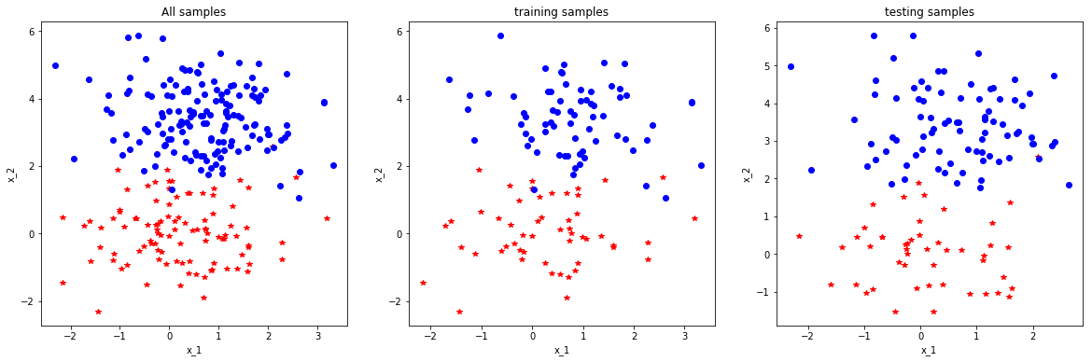

SciKit:

Average error: 0.02307692 Standard Deviation: 0.15014786

Self-developed:

Average error: 0.18461538 Standard Deviation: 0. 38798524

Experiment 2,

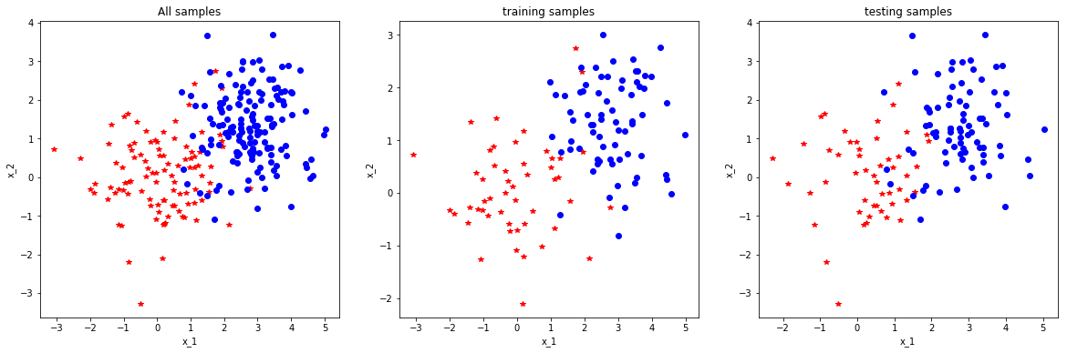

SciKit:

Average error: 0.09230769 Standard Deviation: 0.28945981

Self-developed:

Average error: 0.24615385 Standard Deviation: 0. 43076923

The model of scikit learn is better than self-developed. After several times tests, the accuracy of Self-developed is around 80%. The accuracy of scikit is more than 90%.

**Part II,**

|  |  |  |  |  |  |  |  |  |  |  |  |  |  |  |  |  |  |  |  |  |
| --- | --- | --- | --- | --- | --- | --- | --- | --- | --- | --- | --- | --- | --- | --- | --- | --- | --- | --- | --- | --- |
| Image ID | 1 | 2 | 3 | 4 | 5 | 6 | 7 | 8 | 9 | 10 | 11 | 12 | 13 | 14 | 15 | 16 | 17 | 18 | 19 | 20 |
| True class | C | C | C | C | C | D | D | D | D | D | D | D | D | M | M | M | M | M | M | M |
| Predicted class | D | C | D | D | M | D | D | C | C | M | M | D | C | C | C | M | M | D | D | M |

Notes: C, cat; D, dog; M, monkey

|  |  |  |  |
| --- | --- | --- | --- |
|  | Prediction  Cat (C) | Prediction  Dog (D) | Prediction  Monkey (M) |
| GT: Cat (C) | 1 | 3 | 1 |
| GT: Dog (D) | 3 | 3 | 2 |
| GT: Monkey (M) | 2 | 2 | 3 |

Precision: Recall:

Cat: $\frac{1}{6}$ Cat: $\frac{1}{5}$

Dog: $\frac{3}{8}$ Dog: $\frac{3}{8}$

Monkey: $\frac{3}{6}$ Monkey: $\frac{3}{7}$

**Part III,**

Data,

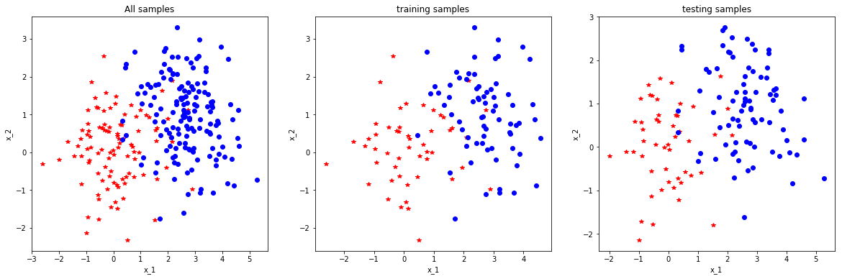

Result:

SciKit:

Average error: 0.09230769 Standard Deviation: 0.28945981

Accuracy: 0.9076923

Confusion matrix:

|  |  |  |
| --- | --- | --- |
|  | Prediction: 0 | Prediction: 1 |
| GT: 0 | 46 | 4 |
| GT: 1 | 8 | 72 |

|  |  |  |
| --- | --- | --- |
|  | Class 0 | Class 1 |
| Precision | 0.851852 | 0.947368 |
| Recall | 0.92 | 0.9 |

Self-developed:

Average error: 0.16153846 Standard Deviation: 0.36802688

Accuracy: 0.83846153

Confusion matrix:

|  |  |  |
| --- | --- | --- |
|  | Prediction: 0 | Prediction: 1 |
| GT: 0 | 29 | 21 |
| GT: 1 | 0 | 80 |

|  |  |  |
| --- | --- | --- |
|  | Class 0 | Class 1 |
| Precision | 1 | 0.792079 |
| Recall | 0.58 | 1 |